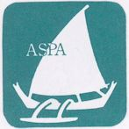～～～～～～～～～～～～～～～～～～Association of South Pacific Area
ASPA
３－８－５－８０1,Toyosaki, Kita-ku, Osaka, Japan #５３１－００７２
℡81-６－６３７６－１１５１；Fax81-６－６３７１－９３３７；Email:info＠aspa-osaka.com

～パプア・ニューギニア～ＰａｐｕａＮｅｗＧｕｉｎｅａ
☆ASPA~PNG No１５th Aid program ’1７☆

*Visiting Itinerary：Sep20th,Wed～Oct 4th,Wed
Depart: Sep 20th,Wed 21:15 TokyoNarita by PX055
Arrival : Sep 21st,Thur 05:05 POM
Depart: Sep 21st,Thu15:20 POM by PX126
Arrival: Sep 21st,Thur 17:30 Wewak Staying in Wewak Boutique Hotel
Sep 22nd,Fri After doing shopping and having lunch, moving to Sowam Village
We should rent a PMB in the afternoon on Sep 22nd.
Depart: Sep 26th,Tues Moving back to Wewak In Wewak Boutique Hotel
Mr.Yokoyama with Jacob
Depart: Sep 27th,Wed 06:10 Wewak by PX 123 Arrival: 08:20 POM
Depart: Oct.3rd,Tue Moving back to Wewak In Wewak Boutique Hotel
We should rent a PMB in the afternoon on Oct ^{3rd.}
Deaprt: Oct.4th,Wed 06:10 Wewak by PX123
Arrival: Oct 4th,Wed 08:20 POM
Depart: Oct ４th, 14:10 POM byPX054 Arrival: 20:05

*Purpose : ①Checking the power unit in Sowom
②Building the new guest house in Kaok village being assisted by carpenters in Sowom.
③Giving the first-aid medical treatment to the people of
Kaok & training 8 ladies in Kaok to be assistant nurses in cooperate with those assistant nurses in Sowom as we did in Sowom.
④The 4th phase of the Charcoal project in Sowom village
Workshop & meeting with those leaders to discuss their self-efficient business possibility to develop: Battery charging, Charcoal production
⑤Building up the ASPA’s Aids network in PNG
⑥Courtesy visit to the Japanese Embassy,

*Cooperators：Japanese Embassy to POM, Japan Business Lines Corp.Paramana&Sowom village,
～Ａｐｉｎｕｎ～ＴｅｎｋｙｕＴｒｕ～Ａｐｉｎｕｎ～ＴｅｎｋｙｕＴｒｕ～

Introduction

This is our 15th aid program in Sowom&Kaok,East Sepic province, PNG.
Over these17 years since the 1st aid party was sent to Sisano Lagoon, Aitape damaged by Great Tsunami in1998, the ASPA’s aid program in PNG has been held under the friendship with the Sowom villagers and many local people’s cooperation.
Thanks to our longtime interrelationship, we are pleased to have accomplished our first official project in Sowom in 2007 named ”The installment of the Small-sized Hybrid Clean Energy Unit into Sowom Village” with the Grant Aid for Japanese NGO’s Project.
Meantime, not only our visit to PNG, but also Jacob, one of the leaders of Sowom and some youth could visit Japan to learn the skill of producing coconut soap.
It is my privilege to have learned that the Sowom was selected as a model village of its environmental subsidy program by the local government. I hope that our skill aids, such as building a guest house and a kit of bed by local materials will be of help to fulfill their simple lives by training the youth generation to survive.
Not only to continue our program in Sowom, but also to expand our network, in 2013 we had our charcoal project in Paramana villge, Aroma Coast arranged kindly by MrGaikovina Kula whose son, Raula is now working for the Osaka University as an assistant professor.
Focusing the 6 purposed mentioned on the front page, we would like to share our technical idea with PNG local people and let us appeal how precious to act in PNG, the most eco-advanced country. .Be pleased to make an action for others no matter where you are. Kenji Matsumura, Leader of the ASPA~PNG 15th Aid party
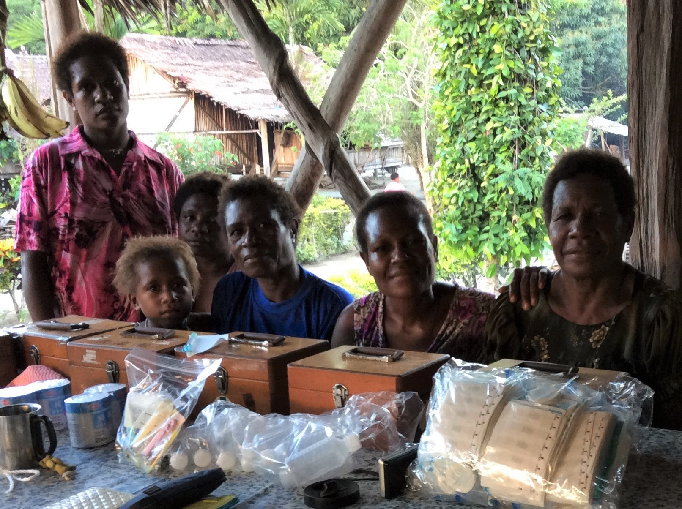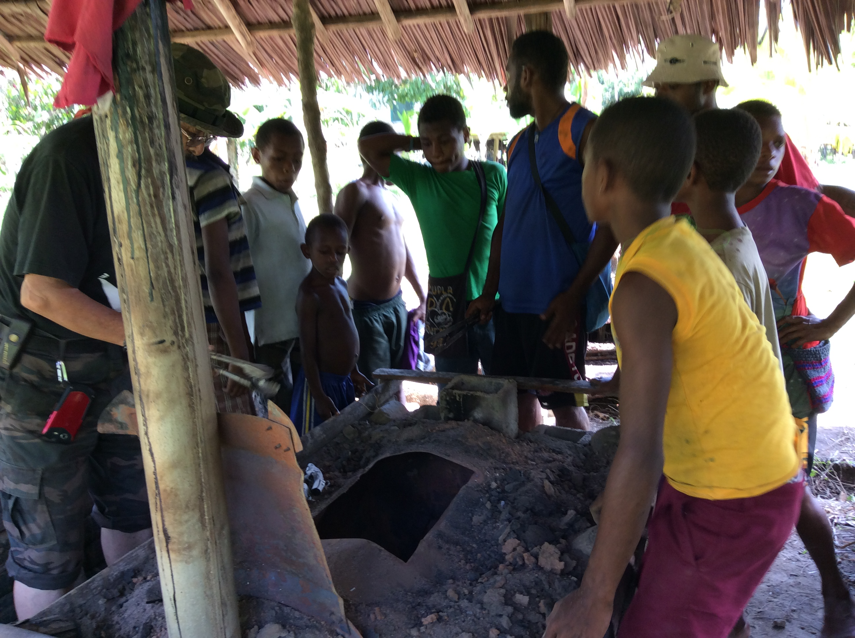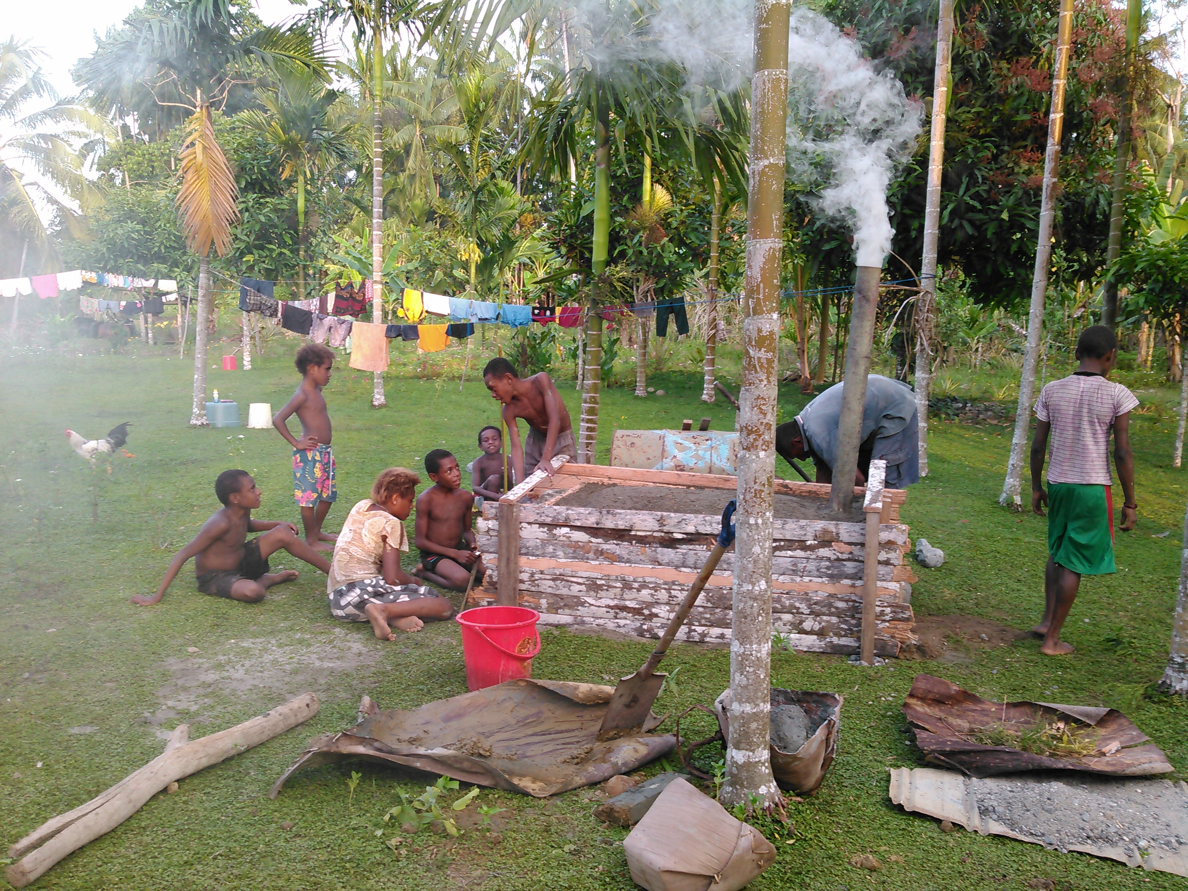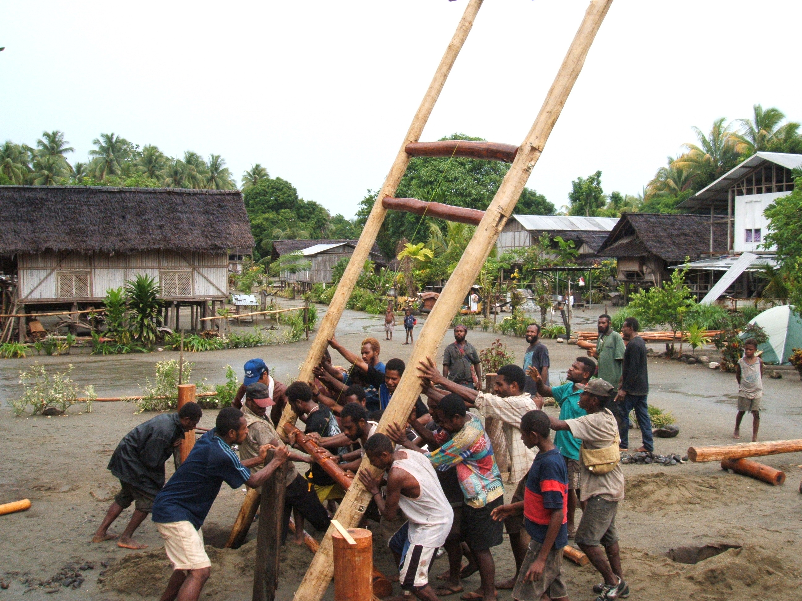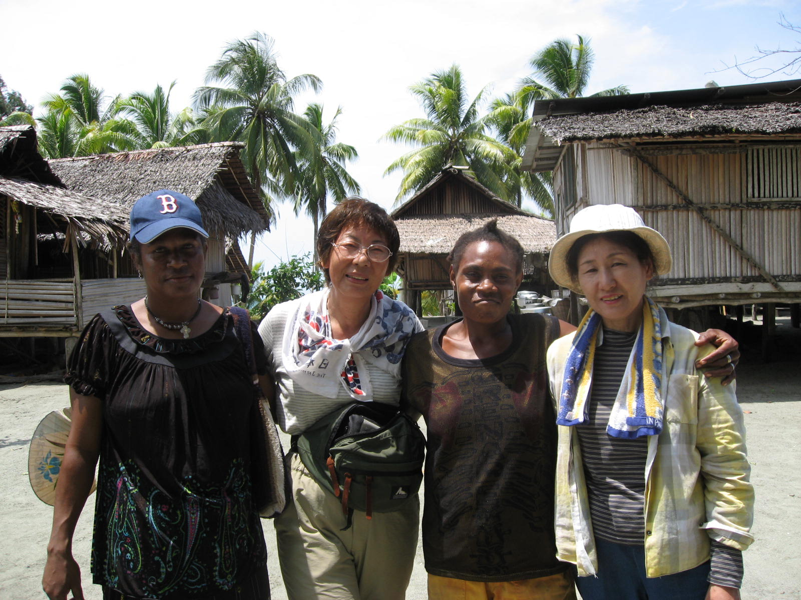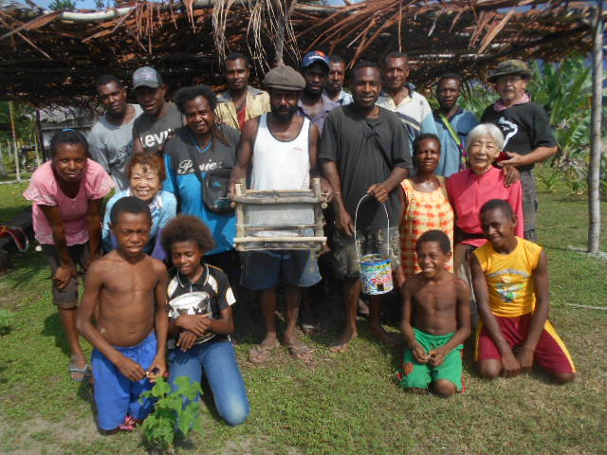

＜The ASPA~PNG No15th Aid Party Member Listing＞
Occupation Name Sowam Visit Experience
Leader Mr.Kenji Matsumura 16
Sub leader Mr.Yoshiaki Horiuchi 11
Nurse Ms.Reiko Takeshima 5
Assistance Mr.Kazushi Yokoyama 2
Nurse Ms.Makiko Sugiyama 1
Artist Ms.Mari Ichinose 1
Pianist Ms.Azumi Shinohara 1
Coordinator Ms.Mieko Hamasaki 15

